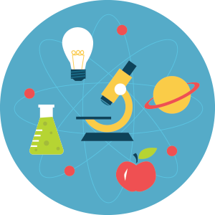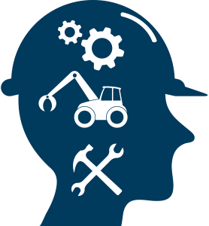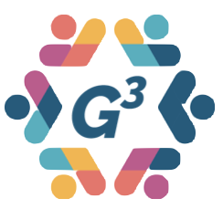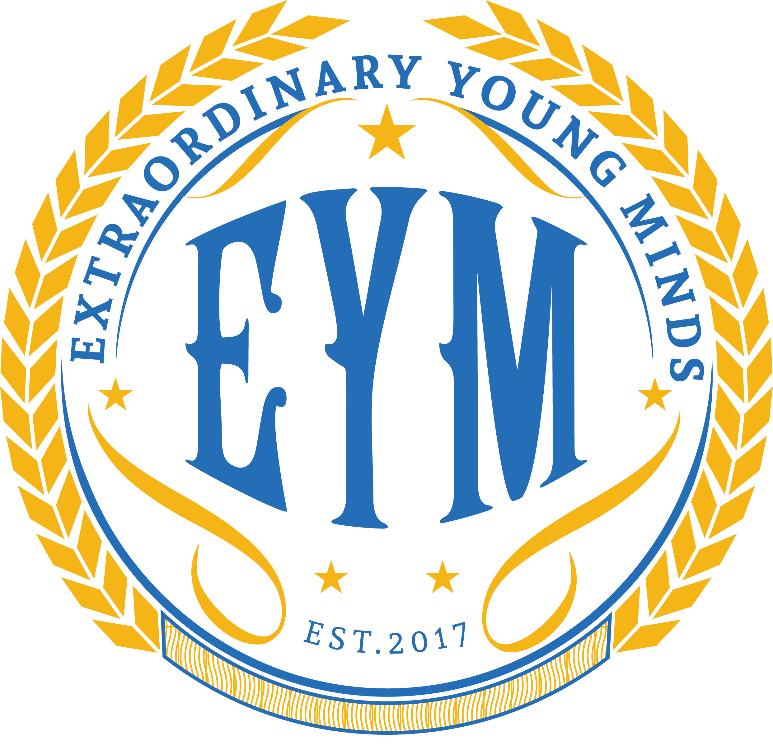



[This Photo](http://shroomery.org/forums/showflat.php/number/21979269) by Unknown Author is licensed under [CC BY-SA-NC](https://creativecommons.org/licenses/by-nc-sa/3.0/)

**EYM** is a focused branch of G3 Community Services’ efforts to support character development through introductions to technology, innovation, and the arts. We conduct a series of workshops and STEAM activities while adding principles of leadership, education, and community empowerment.

**FREE FOR CHILDREN OF ALL AGES!**

Are you interested in **SCIENCE, TECHNOLOGY, ENGINEERING, MATH?** Do you want to learn more about things like **PAINTING, MUSIC,** and **LITERATURE?** Come join us and support Extraordinary Young Minds (**EYM**) Sunday workshop. We meet the **3rd** Sunday of every month.

Join us:

**Sunday, September 15th**

from **4pm-6pm**

Stafford Hospital

Conference Room 5 & 6

101 Hospital Center Blvd

Stafford, VA 22554

RESTORE | INSPIRE | EMPOWER

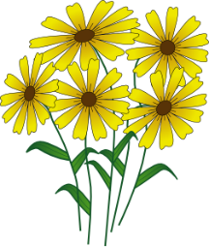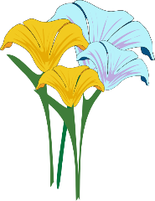

Improving Lives and Strengthening Communities